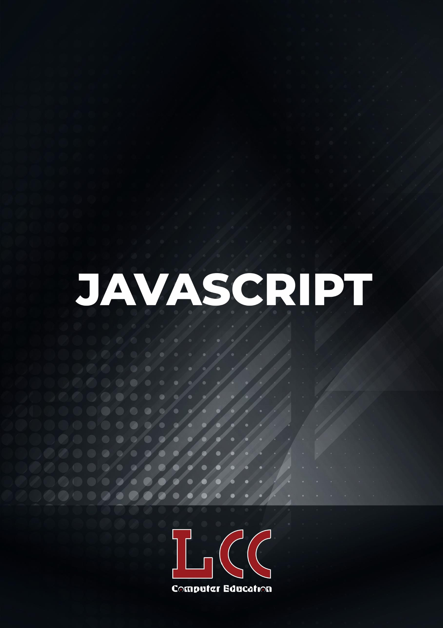

Microoft

Course Name-Javascript



JavaScript

Session1-Introduction

* Theory of JavaScript
* Uses Of JavaScript
* How to write a Script

# Session 2-Basics elements of JavaScript

* Variables
* Operators
* Data Types
* Statements Theory
* Sample Examples

# Session 3-Functions

* Theory of Functions,
* Dynamic Effects

# Session 4-Conditions

* If ...Else Statements Theory and Example With Events

# Session 5-Switch

* Theory and Examples With Events

# Session 6-Loop

* Theory Loop and Example With Events

# Session 7-JavaScript objects

* How to create JavaScript objects; Create Array, Date, String, Math

# Session 8-JavaScript Events

* Explain Events with Examples

# Session 9-JavaScript Change HTML Attributes HTML Styles

* Explain with Examples

# Session 10-BOM elements

* Browser Objects
* Window Objects
* History Objects

# Session 11-DOM elements

* Document Object
* Events
* Functions

# Session 12-Validation



* Form validation, Number Validation, Character Validation, Email Validation
* Add Full Form Validation in to a Page

# Session 13-OOPS



* Object, Class, Encapsulation, Inheritance, Polymorphism